Generics Points

1. Create two folders as backend and frontend
2. Inside backend folder create Eureka Server project with two starter web starter and eureka server

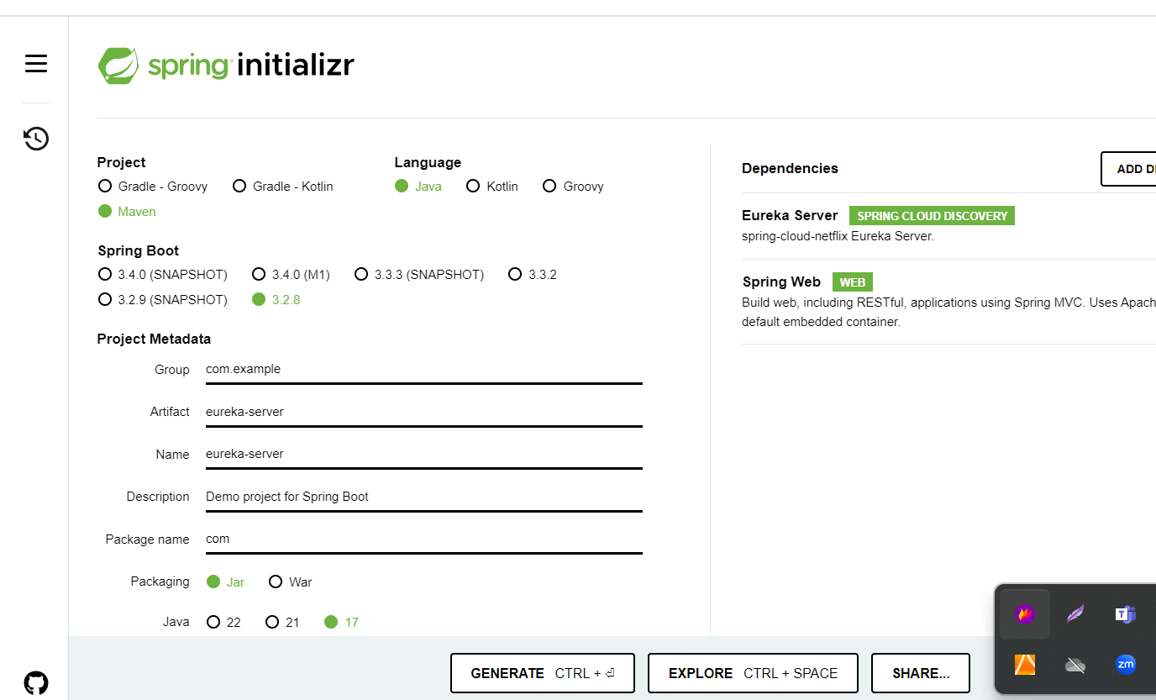

1. Create micro-service-app

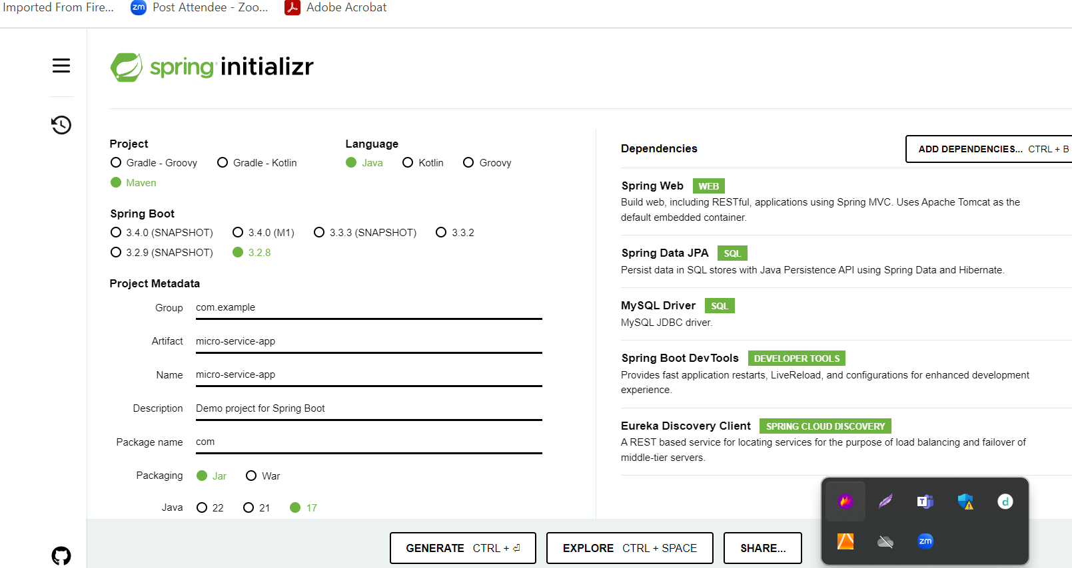

1. Create more than on rest api depending upon the application requirements.

Here we create simple rest api to retrieve student information.

1. Now we will create front-end app using angular to access these rest api.

ng new front-end-app

routing 🡪 yes

styling 🡪 css

ng g c student

ng g class student

ng g s student

**below link contains capstone project demo app**

<https://github.com/Kaleakash/capstone_project_test.git>

create docker compose file and run the four containers

1. Mysql container
2. Spring eureka server container
3. Micro service container
4. Front end container

Test in local machine

Run Jenkin software using jennkins.war file

To build angular project we need node js and to build spring boot project we need maven tool